|  |
| --- |
| **Mr. Hara’s Science 8 Syllabus**  NP3 School  Room H-3  cid:image005.jpg@01CA9F52.30E996F0  Email: [chara@n](mailto:chara@n)atomasunified.org |

**Intro:** Welcome to 8th grade Science! This is a hands-on course which teaches the Next Generation Science Standards. Together, we will answer (and raise even more) questions about earth, physical, and life science as we know it. Throughout the year we will connect the lives we lead as individuals to one another, our environment, and the global community. Engineering practices and scientific thinking will be used as lenses to explore the world around us. Our study will delve into topics including space, Earth history, forces, motion and energy, and natural selection and evolution.

**Yearly Goals:**

* Students will remain curious about the natural phenomena of the world and use scientific and mathematical reasoning for explanation.
* Students will be able to critically analyze, form hypotheses, and evaluate scientific evidence
* Students will be resourceful in their continuing quest for knowledge.
* Students will work together to solve math and science problems as a community of learners.

**Class Website:**

https://natomasunified.org/np3m/class/science-8-2/

AND

http://mrharanp3.weebly.com

**Grading:**

Grades *are earned, not given!*

NP3 uses a standards based report card to assess student proficiency on content standards. Each standard is graded on a 1-4 scale: Below Basic (1), Basic (2), Proficient (3), and Advanced (4). Families are able to see their student’s progress on Infinite Campus. Students will have diverse and numerous opportunities to prove proficiency in each content standard.

**Absences/Make-up Work**

If a student is absent, they are expected to approach their peers about the missed days’ material and assignments. Students can find all of the missing material in the daily divider located near the classroom door and/or on the class website.

**DAILY Required Materials:**

* Science Binder (1 inch) or Science Divider in Binder
* 2 Spiral Bound Notebooks
* Loose notebook paper
* Pens (blue, black, and red)
* Pencils and erasers
* Highlighters

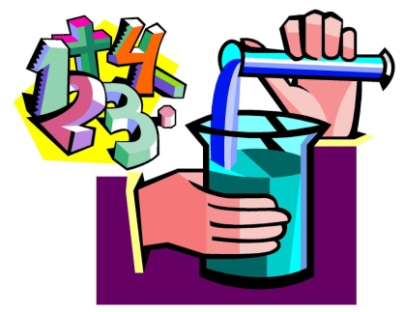

**Classroom Expectations:**

* **Students are at school to learn**
  + Students will not do anything to compromise the emotional or physical **safety** of themselves or others
  + All students will be **respectful** of people, property and the learning process
    - No student will interfere with the learning of another student
    - Students will take turns when speaking
    - Each student will work cooperatively in his/her learning community
    - No food or drinks in the classroom (except water)
    - Language will not be offensive, insulting, nor inappropriate for a public setting
    - Clean up after oneself
    - Personal devices should be left in student backpacks and will be sent to office for pick up.
  + All students will take **responsibility** for his/her own learning
    - Students will take an **active** part in the learning process
    - Students will raise their hands if they have a question or comment
    - Students will be prepared with completed assignments and required materials daily
    - Students will be in their assigned seat, quiet, and attentive when class begins
    - Students are responsible for work missed while absent and will make it up in a timely manner

**Taking Responsibility for One’s Actions:**

Our class is a community built on respect, kindness, being prepared and responsible. Students at NP3 are accountable for their actions in order to maintain a positive learning environment.

Reminders of student agreement to these expectations are offered accordingly.

1.) A verbal warning

2.) Refocus form – written reflection of actions and consideration of student-initiated logical consequence

3.) Time out with work

4.) Referral

All of the rules in the NP3 Middle School Handbook apply to this class. The school’s academic honesty code applies to all assignments and tests. Cheating by copying, sharing answers on assessments, plagiarism, or any other method will not be tolerated and result in an academic referral.

**-----------------------------Please sign and detach for student turn in---------------------------**

**\*\*Return to Mr. Hara by Wednesday, 8/9/2017\*\***

Please indicate that you have read the syllabus for 8th Grade Science by signing below:

Student Name (Please print): _____________________________________________

Student Signature: _____________________________________________________

Parent/Guardian Name (Please print): _______________________________________ Parent/Guardian Signature: ______________________________________________

*We will be using Discovery Education as a foundational piece of the Science 8 curriculum; please check accordingly.

______ Yes, my student has computer *and* internet access at home.

______ No, my student does not have computer *and* internet access at home.